Task-04(Git And Github)

1)Install git.

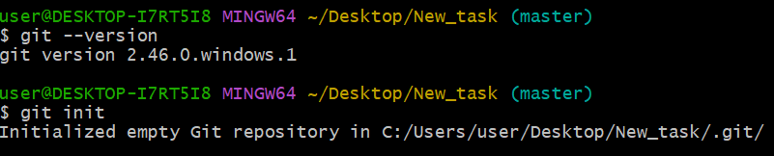

2)Create a repo in github with README.md and .ignore file. 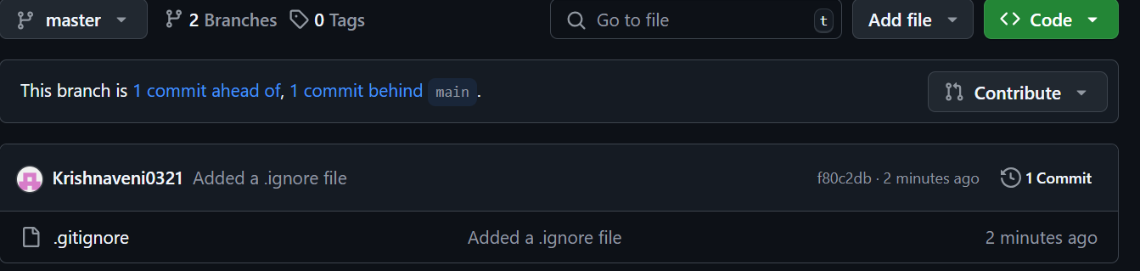

3)Clone the created repo to local. 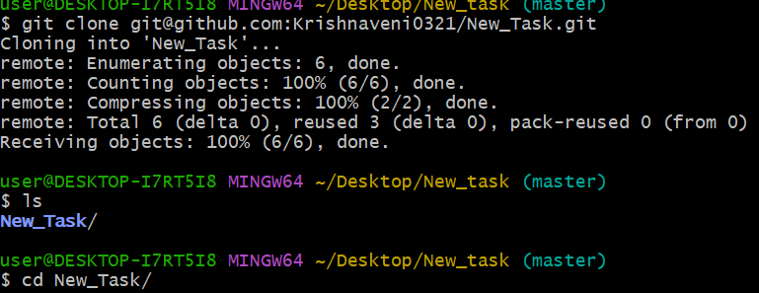

4)Create two files in local repo. 

5)Commit two files and push to central Repository.

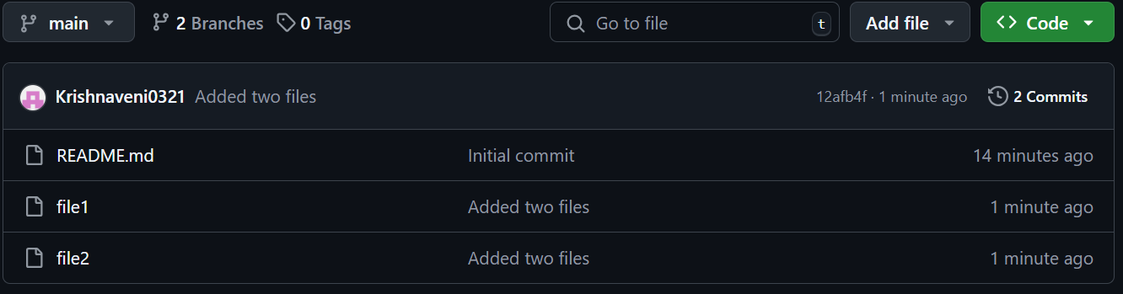

6)Create a branch in local and create a sample file and push to central. 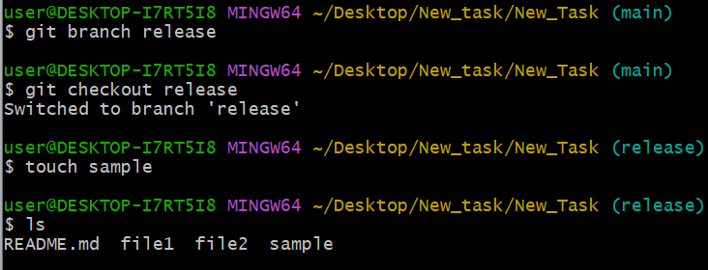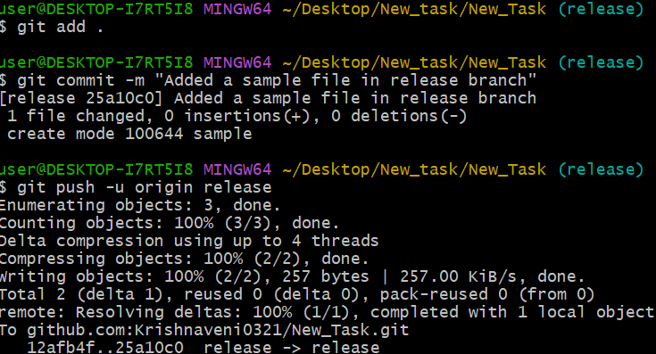

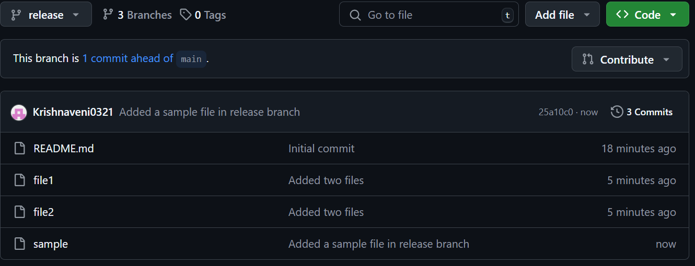

7)Create a branch in github and clone that to local. 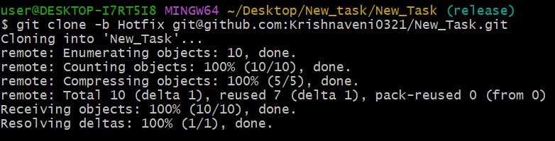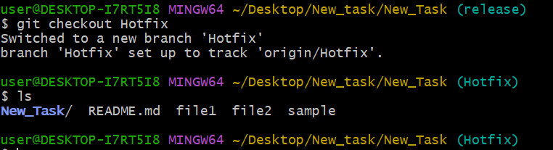

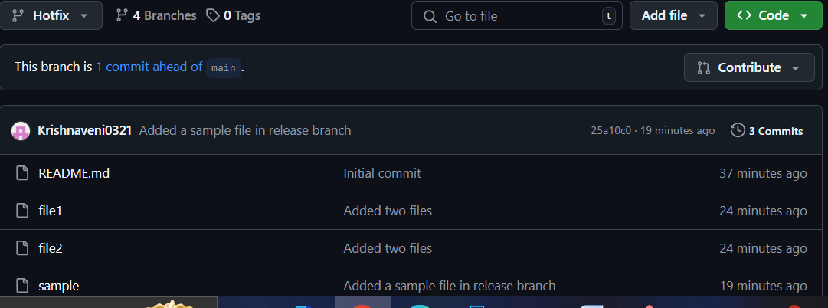

8)Merge the created branch with master in git local. 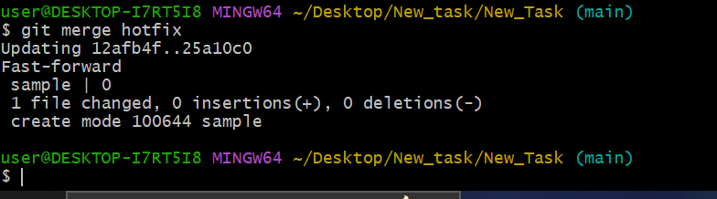

9)Merge the created branch with master in github by sending a pull request. 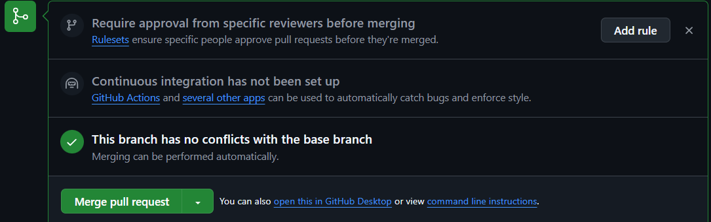

  
10)create a file in local and send that to branch in github. 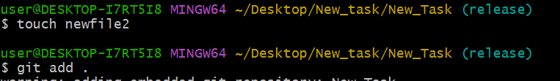

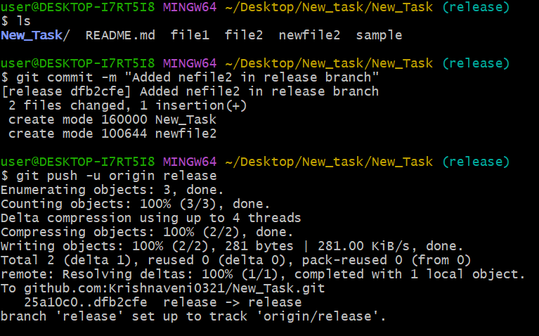

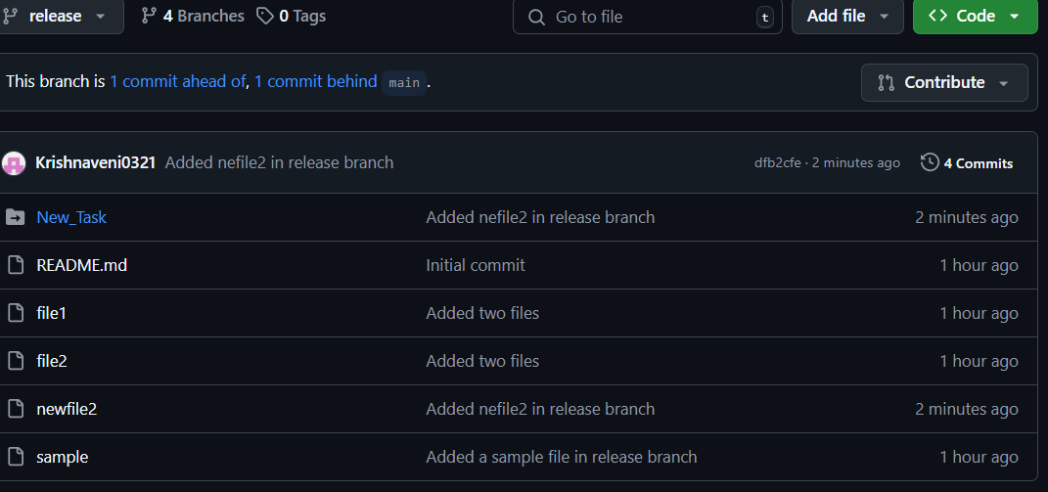

11)clone only a branch from github to local. 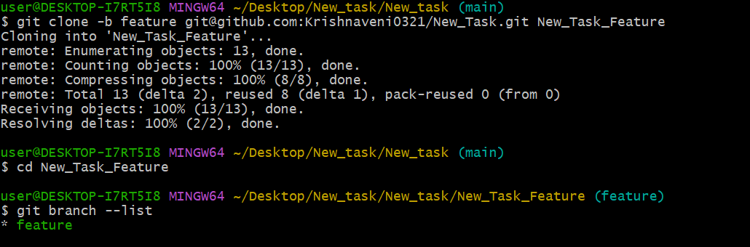

12)create a file with all passwords and make that untrackable with git. 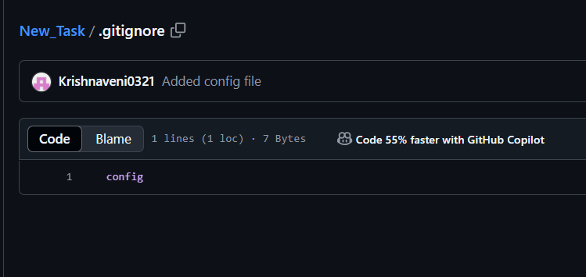



13)make a commit and make that commit reset without savings changes.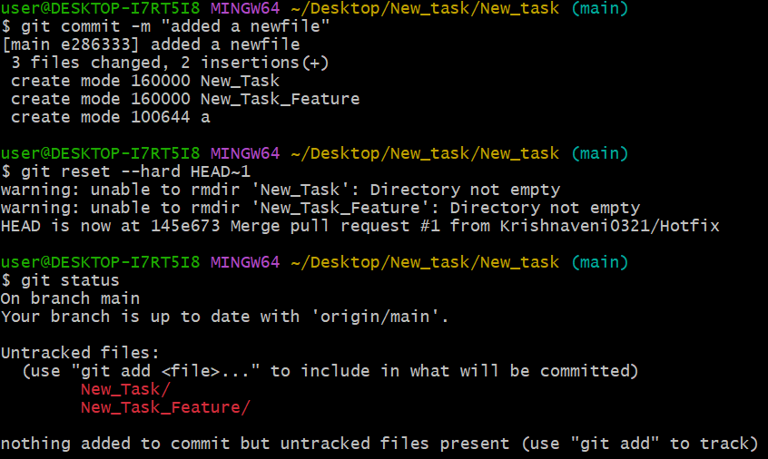  
14)Revert a commited commit to the older version. 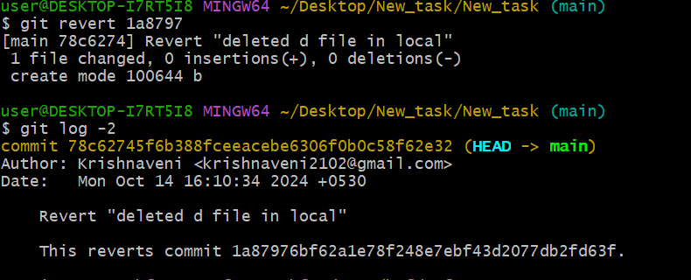

15)push a file to stash without savings the cha nges and work on another file.

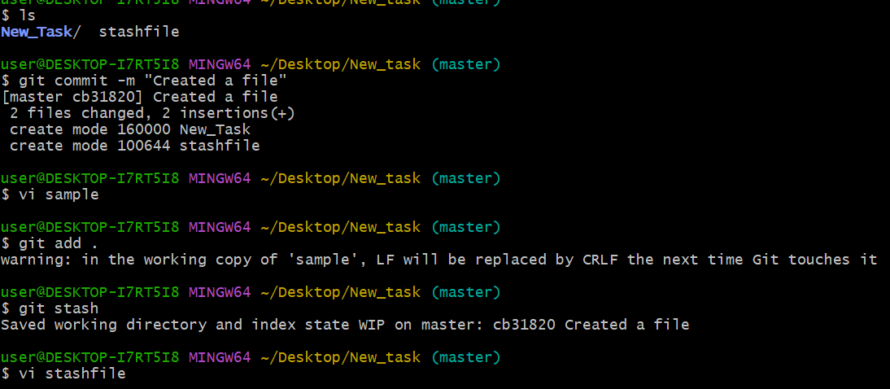

16)undo the stash file and start working on that again.

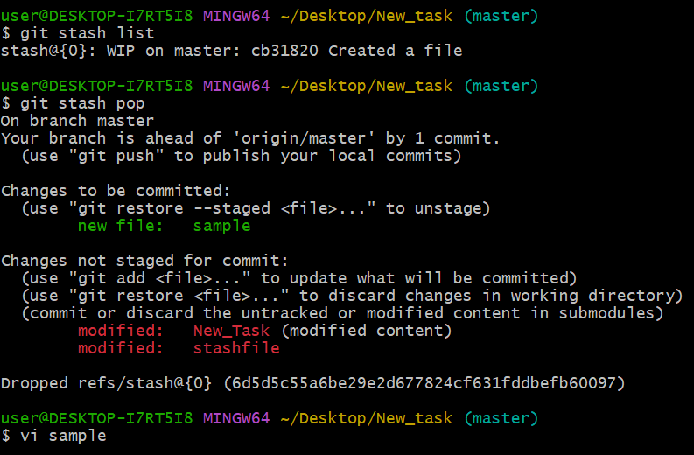

17)generate a ssh-keygen and configure into github. 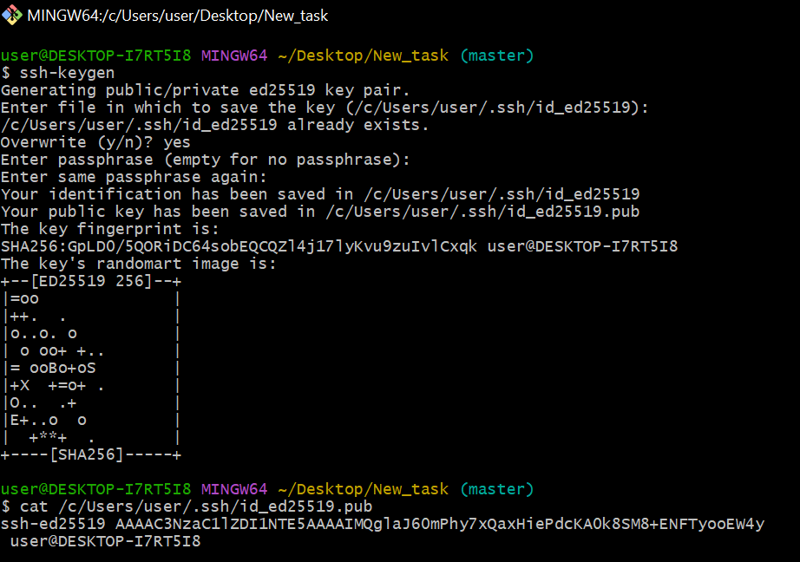

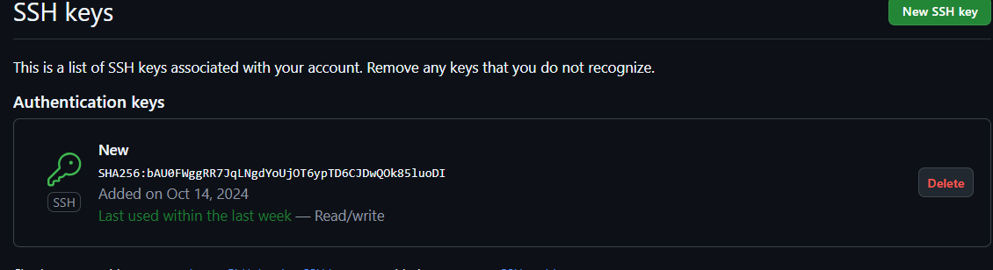

18)configure webhooks to github.

19)basic understanding of .git file.

A Git repository is the . git/ folder inside a project. This repository tracks all changes made to files in your project, building a history over time. Meaning, if you delete the . git/ folder, then you delete your project's history.

20)Check all the logs of git. 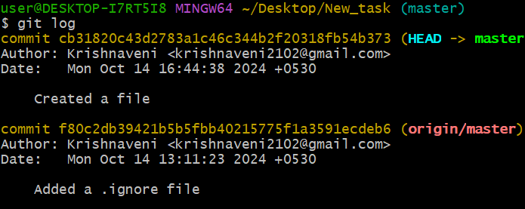

21)Rename the commit message. 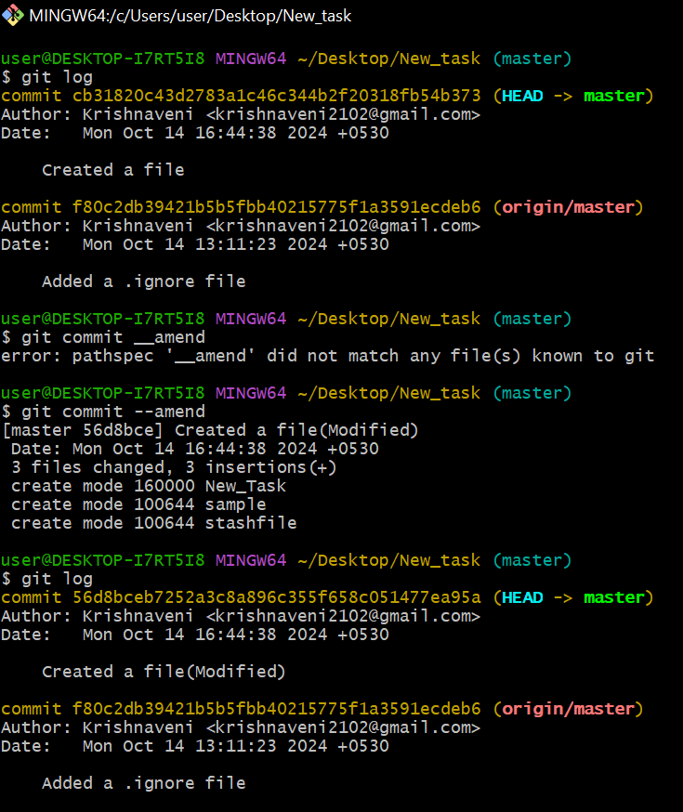

22)Merge multiple commits into single commit.

